## Design System Architecture

### Server

The server will be responsible to address all the user agents and to manage the streaming server. To make all this possible, a main interface is responsible to interconnect all the parts of the system. Among this parts we can include: a web services interface to communicate with both agents, administrator and client; a database to store all the client’s information and video contents; a streaming server responsible to stream the video content to the clients interface through the appropriate channels.

Today, the most used approach in this kind of environment is the content delivery network (CDN). This CDNs have several servers spread around the network close to the costumers to provide a better streaming solution. Meaning that if the use of the server starts to increase, another. Computer and network connection may be setup to provide sufficient bandwidth for a reliable service.

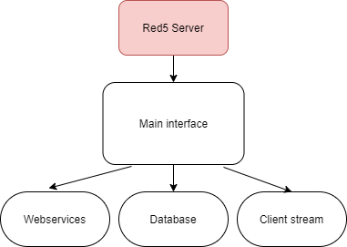

Server’s Diagram

### WebAdmin

To customize and configure the servers behavior and working requisites, a web interface shall be created. This environment consists of a webpage designed with HTML5, CSS3 and a PHP framework to implement all the needed tools. The interface will communicate with the server via a web services API and it’s important to highlight that this type of dimensioning will give us a decentralized solution. With the admin interface, video files and contents which can be retrieved from the appropriate websites, will be uploaded to the servers local storage or database respectively. The video’s information must be retrieved from official websites like IMDB, this information is required to be serialized by the admin’s interface and then uploaded to the servers

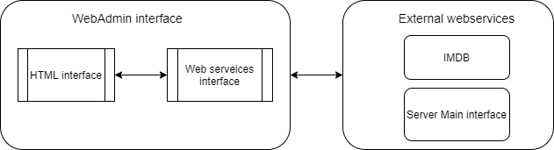

WebAdmin’s Diagram

### Client

The Client’s only concern may be to properly play the video stream, but this application should use the state-of-art tools to create the best multimedia experience and usability. One of the programming tools ideal for this part of the project is the JavaFX platform because of its capability to bring a feature-rich application. Every communication will start in the client. After a successful login to the services, he will be able to search for the content available in the server. When it chooses a movie/series, all the respective information will be shown, and if it’s eligible he can play the content.

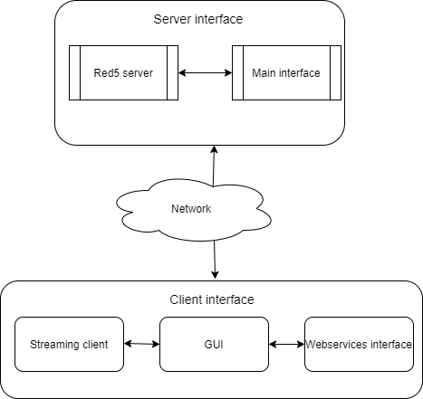Client’s Diagram